Blog Nest Documentation
A secure, modular REST API platform for creating, managing, and exploring blog content.

Description
The Blog Nest backend is a secure, modular REST API platform designed to simplify blog creation and content management. Built with Node.js and Express.js, the application uses MongoDB as its primary database with Mongoose as the ODM layer for schema modeling, validation, and data access.
The platform supports blog creation, content management, user authentication, comments, and structured access control. It provides a centralized backend that can be consumed by web, mobile, or API clients through REST endpoints.
Security is a core part of the architecture: JSON Web Tokens (JWT) provide stateless authentication, bcrypt.js hashes and verifies passwords, and authentication middleware protects sensitive routes by validating tokens and attaching the requesting user to every guarded request. The backend also supports full blog CRUD, threaded comments, request-body validation, and centralized error handling.
Designed with a layered architecture (routes → controllers → models), Blog Nest keeps routing, business logic, database operations, and authentication separated for easier development and maintenance.

Scenario-Based Case Study

Background
Priya is a content creator who manages multiple blogs but struggles to create posts quickly, organize reader feedback, and securely manage her published content.

Problem
- Creating and organizing blog posts manually takes considerable time.
- Long-form content can be difficult to manage and present in an organized way.
- Reader feedback is scattered because there is no structured comment system.
- There is no secure way to control who can edit or delete a given post or comment.
- User identity and ownership need to be verified before protected operations are performed.

Solution
The Blog Nest backend delivers a centralized, JWT-secured API that separates business logic from any frontend. It provides user authentication, blog CRUD operations, comments, validation, and ownership checks so that only authorized users can modify or remove their own resources.

Usage
- Author Usage: Registers and logs in, creates blog posts, updates or deletes their own posts, and manages comments.
- Reader Usage: Browses published posts and reads available blog content.
- Authenticated Reader Usage: Adds comments to blog posts after authentication.

Outcome
By moving content management, validation, and access control into a dedicated backend, Blog Nest provides an organized environment for creating blog posts, maintaining comment threads, and protecting user-owned content.

1. Software Requirements
- Operating System: Windows 10/11, macOS, or Linux.
- Node.js (v16 or above): JavaScript runtime for executing the Express server and application logic.
- npm (v8 or above): Package manager used to install and run project dependencies.
- Express.js 4.x: Lightweight framework used to build the REST API.
- MongoDB: Document database for storing users, blogs, and comments.
- Mongoose 7.x: ODM layer for schema definitions, validation, and database queries.
- Postman or Thunder Client: API verification tools for testing routes with sample JSON payloads.
- Code Editor: Visual Studio Code or a similar IDE.

2. Hardware Requirements
- Processor: Intel Core i5 (8th Gen or above) / AMD Ryzen 5 or equivalent.
- RAM: 8 GB minimum; 16 GB recommended for running MongoDB, the Node server, and the editor together.
- Storage: At least 1 GB of available disk space for dependencies and project files.

Epic 1: Project Architecture
Blog Nest exposes a layered REST API. Every incoming request passes through global middleware, is optionally authenticated, is routed to a controller, and receives a JSON response. A central error handler catches failures and returns a consistent response.

Components Definition
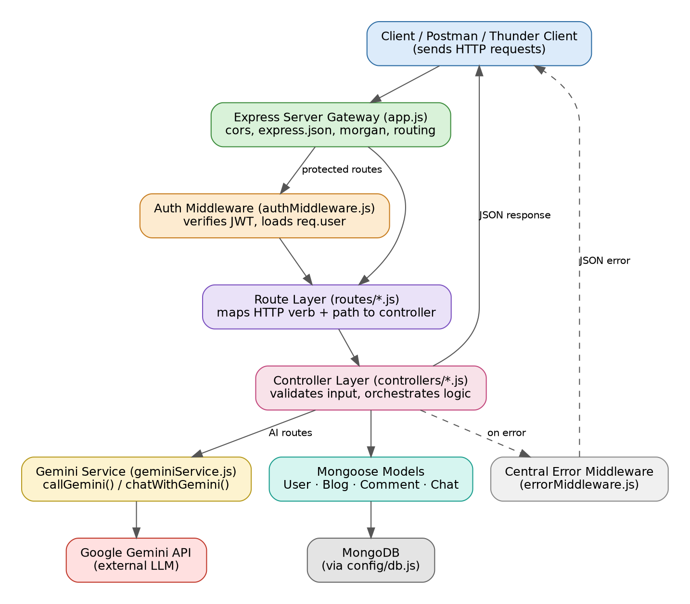
- Client (Postman / Thunder Client / any frontend): Issues HTTP requests and receives JSON responses.
- Express Server Gateway (app.js): Registers global middleware such as cors(), express.json(), and morgan('dev'), and mounts resource routers.
- Authentication Middleware (authMiddleware.js): Reads the Authorization: Bearer <token> header, verifies the JWT, loads the user, and attaches it to req.user.
- Route Layer (routes/*.js): Maps HTTP methods and paths to controller functions and declares request validation rules.
- Controller Layer (controllers/*.js): Validates input, enforces ownership rules, communicates with models, and shapes JSON responses.
- Database Interface Layer (models/*.js + config/db.js): Mongoose schemas translate controller calls into MongoDB operations.
- Central Error Middleware (errorMiddleware.js): Catches errors and returns a consistent JSON error body.

Entity-Relationship (ER) Diagram Description
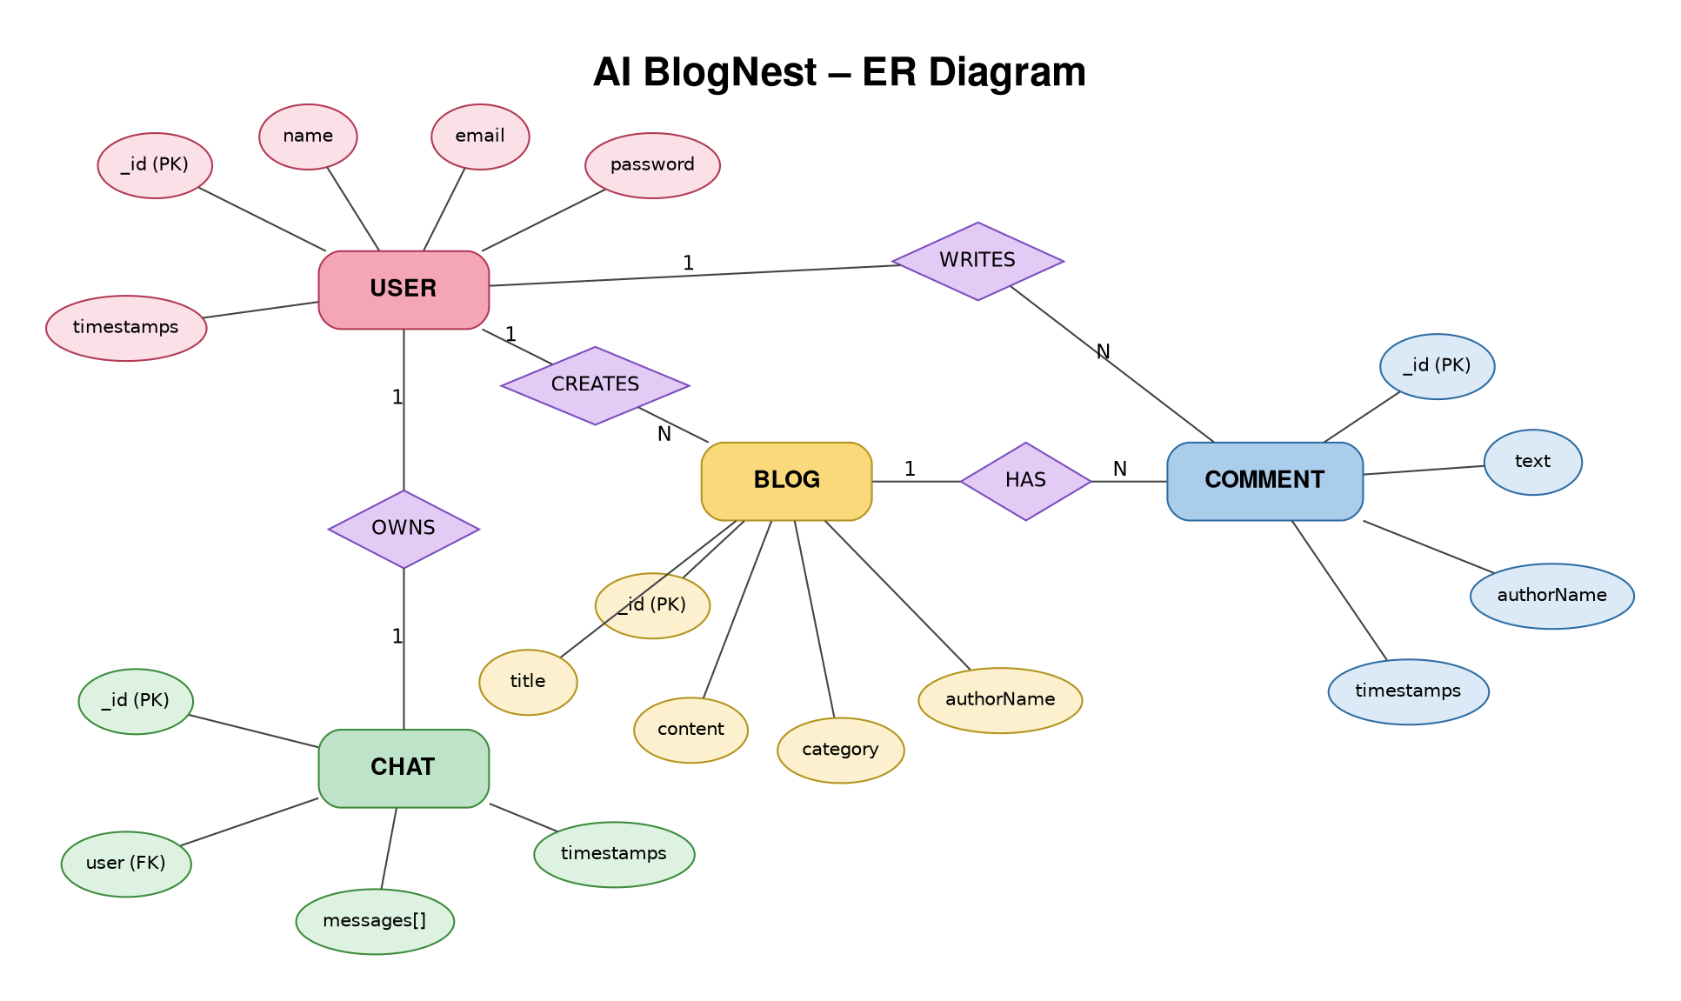
The application persists three main collections/entities, related through ObjectId references.

1. User Entity
- _id (Primary Key – ObjectId)
- name (String, required)
- email (String, required, unique, lowercase)
- password (String, hashed with bcrypt, required)
- timestamps (createdAt, updatedAt)

2. Blog Entity
- _id (Primary Key – ObjectId)
- title (String, required)
- content (String, required)
- category (String, required)
- author (ObjectId, references User, required)
- authorName (String, required)
- timestamps (createdAt, updatedAt)

3. Comment Entity
- _id (Primary Key – ObjectId)
- text (String, required, maximum 500 characters)
- blog (ObjectId, references Blog, required)
- author (ObjectId, references User, required)
- authorName (String, required)
- timestamps (createdAt, updatedAt)

Key Structural Mappings
- User to Blog (One-to-Many): An author can create multiple blog posts.
- User to Comment (One-to-Many): A user can post multiple comments across different blogs.
- Blog to Comment (One-to-Many): Each blog can have multiple comment documents.

Key Features
- JWT Route Guarding: Blocks unauthenticated requests from reaching protected controllers.
- Ownership-Based Authorization: Blog and comment updates/deletes verify the authenticated user's ownership.
- CRUD Blog Engine: Supports create, read, update, and delete operations for blog posts.
- Categorization: Blogs contain a category field for organizing content.
- Comment Threads: Comments are linked to a specific blog and can be managed by their original author.
- Request Validation: Write routes validate incoming request data before controller execution.

Roles and Responsibilities
- Authenticated User (Author): Registers, logs in, creates and manages their own blog posts and comments.
- Guest / Reader: Can read available blog posts without creating content.
- Authenticated Reader: Can add comments after successful authentication.

User Flow
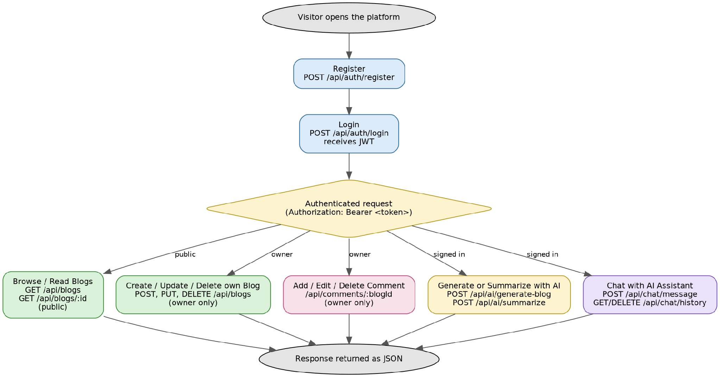
User → Register/Login → Receive JWT → Browse Blogs → Create/Read/Update/Delete Own Blog → Add/View Comments → Logout

MVC Architecture Pattern
The source layout follows the Model-View-Controller pattern to keep data definitions, business logic, and routing separated.

Model Layer (Data Blueprint)
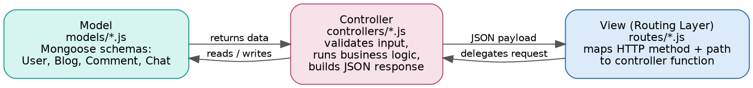
Defined in models/*.js using Mongoose schemas. The schemas enforce required fields, validation, and reference relationships before documents are stored.

Controller Layer (Execution Matrix)
Defined in controllers/*.js. Each controller reads the validated request, applies business rules, checks ownership, calls the appropriate model methods, and returns a JSON response.

View Layer (Routing Network Interface)
As a headless API, there are no server-rendered views. The routing layer wires each HTTP method and path directly to its controller handler.

Epic 2: Project Setup and Configuration

Creating the Project Folder

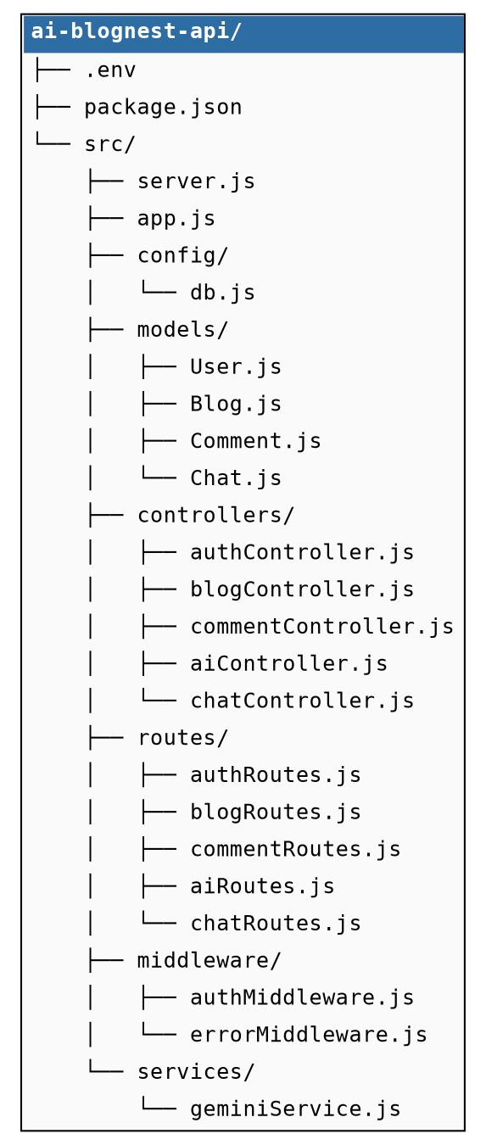
- Create a new folder for the project (for example, blog-nest-api).
- Open that folder in VS Code.
- Create a src/ folder to hold application source code.
- Inside src/, create config, models, controllers, routes, and middleware folders.

Server Setup (npm init)
Open the project folder in a terminal and run:
npm init -y
Install the runtime dependencies:
npm install express mongoose cors morgan dotenv jsonwebtoken bcryptjs express-validator
Install the development dependency:
npm install -D nodemon

Create the Entry Files
- src/server.js – boots the application and starts listening.
- src/app.js – configures Express, middleware, and routers.
Add the run scripts to package.json:
"start": "node src/server.js"
"dev": "nodemon src/server.js"

Epic 3: Backend Development

server.js
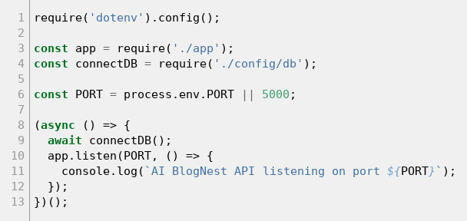
Loads environment variables, connects to MongoDB, and starts the HTTP listener only after the database connection succeeds.

app.js
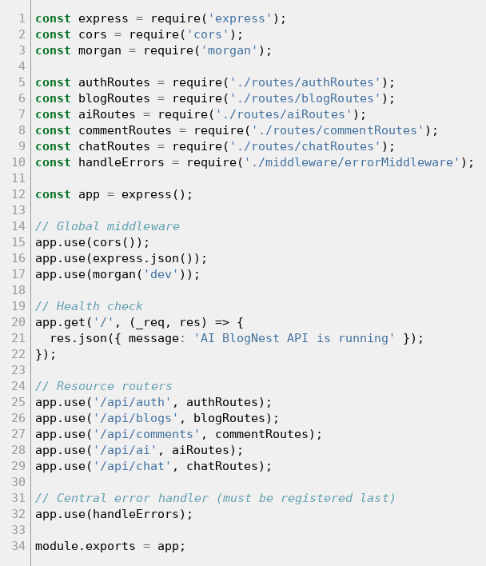
Configures global middleware, mounts resource routers under /api, exposes a health-check route, and registers the central error handler last.

Epic 4: Database Configuration

DB Connection
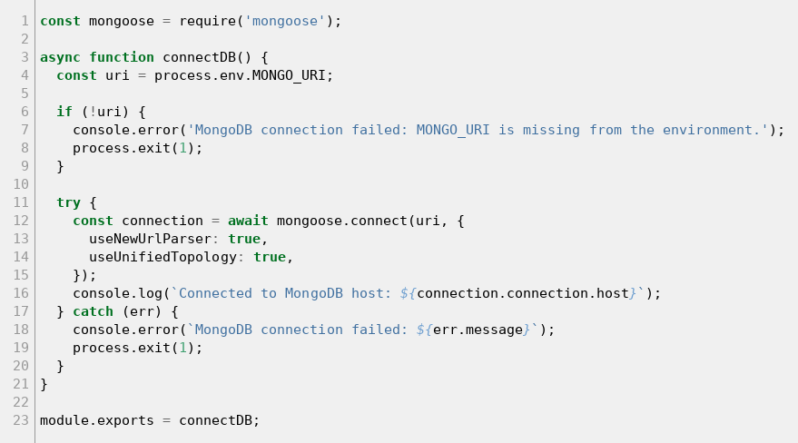
- Configure MongoDB.
- Install Mongoose in the project directory.
npm install mongoose
- Create the database connection module (config/db.js).
- Create the Mongoose schemas and models (models/User.js, Blog.js, Comment.js).

Create Database Connection
The database must connect successfully before the server starts accepting requests. The server connects to MongoDB before app.listen() is called, so configuration or connection errors are detected before the API begins accepting requests.

Mongoose Schema Definitions
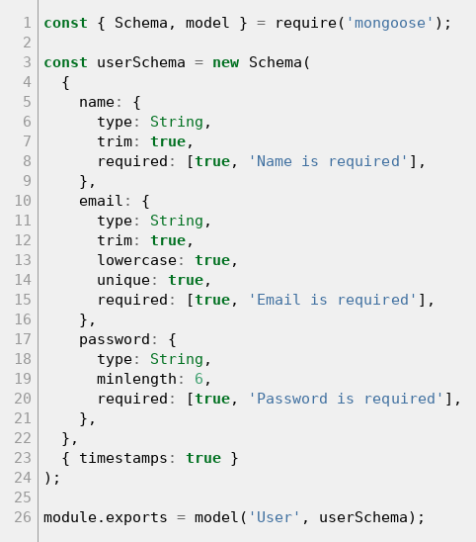
The User, Blog, and Comment schemas define the fields, validation rules, and references required by the application.

Epic 5: Project Executions
- Install Postman or the Thunder Client extension for VS Code.
- Create a .env file with PORT, MONGO_URI, and JWT_SECRET.
- Start the backend server:
npm run dev

API Testing
The API can be tested using Postman or Thunder Client. Representative core flows include user registration, user login, blog creation, blog retrieval, and comment operations.

User Registration
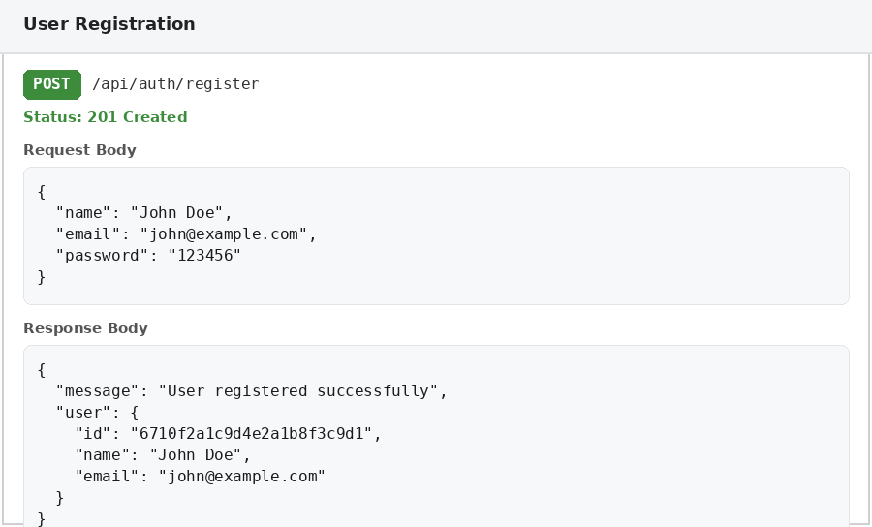
POST /api/auth/register
Sample JSON: { "name": "Priya", "email": "priya@example.com", "password": "******" }

User Login
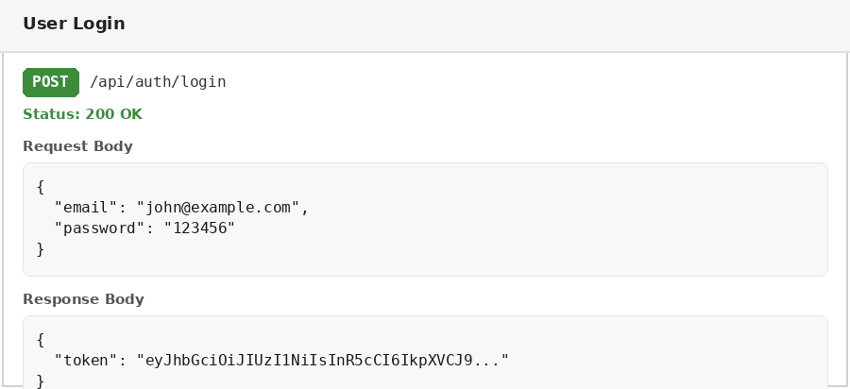
POST /api/auth/login
Sample JSON: { "email": "priya@example.com", "password": "******" }

Create Blog
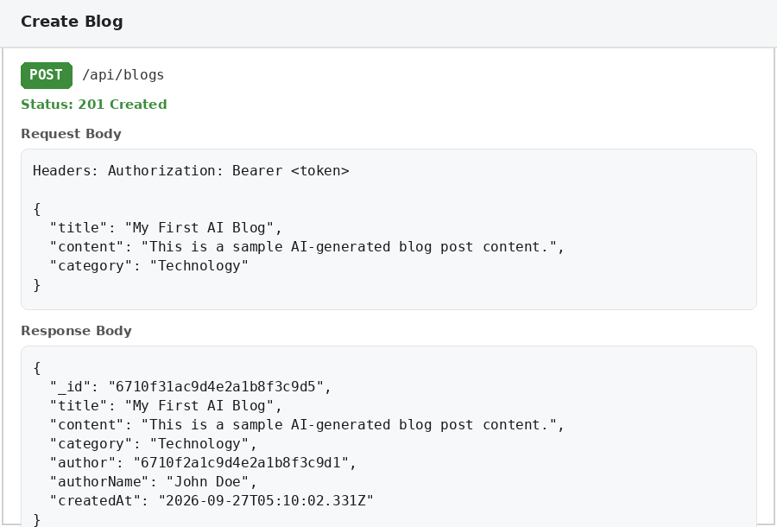
POST /api/blogs
Sample JSON: { "title": "My First Blog", "content": "Welcome to Blog Nest.", "category": "Technology" }

Fetch Blogs
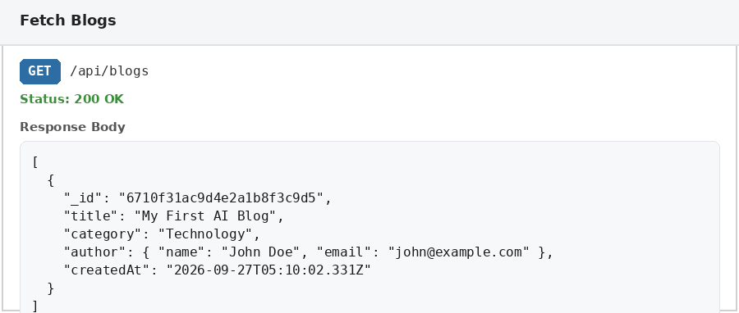
GET /api/blogs

Add Comment
POST /api/comments
Sample JSON: { "text": "Great blog post!", "blog": "<blog_id>" }

Demo Video: AI Blog Nest Code-Explanation video

API Testing Video: API Testing Video

Code Drive: Ai Blog Nest Project Code

